Commission for People with Disabilities
April 27, 2016
Present (Members): Marie Allison, Rick Curtis, Kenzie Gleason, Kristy Stambaugh, Roger Daman, Laura Thomas, Tiffany Bryant, Carla Johnson, Christina Espinosa-Bard, Neena Khanna, Sara Brown. (Visitors): Jeanne Gardner, Amy Brown, Hannah Thomas, Natasha Niro, Angela Wallace.
Call to Order & Introductions: The meeting was call to order by Chair Laura Thomas at 9:32 AM and those in attendance introduced themselves.
Approval of Minutes/Treasure’s Report: Motion made by Kristy Stambaugh, second by Rick Curtis and was passed.
Public Comment:
- Tiffany Bryant introduced Amy Brown of the Bob Brown House which provides housing to individuals with disabilities. Amy Brown discussed their history and stated that they are working on getting a grant to expand their building so that they can have more rooms available to individuals with disabilities in the community.
New Business:
- Member Leadership Award was given to Council Member Peggy Henson.
- ADA and gas pumps: Roger stated that he is waiting to learn who the new state ADA coordinator. Kristy Stambaugh recommended that businesses that do provide these services be given kudos on Council Corner and encourage other business to do so as well.
- Report from Downtown Survey, Formerly Latitudes: Laura Thomas stated that Diana Larmay has bought Latitudes. They are collaborating with Transylvania and plan to have a website available soon.
- Loan Closet Idea: Laura Thomas stated that this will be tabled for the next meeting.
- Invite to Art Crosby (Fair Housing): Laura Thomas reported that she would like for Art Crosby to come to our next meeting.

Old Business:
- Commission Logo: Roger Daman reported that he was given the following logo
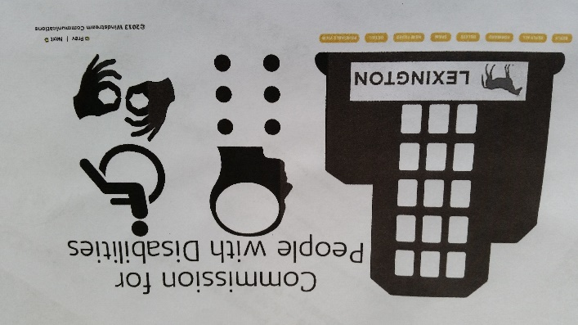
which was created by Chelsea. Kenzie Gleason stated that she would like to have a logo that symbolized inclusion. ACTION ITEM: Kenzie Gleason and Roger Damon will research concepts.
- Summer market on Maxwell: Daman Rogers stated that he has given the Lexington Center information on what needs to be done and the costs. He stated that he will follow up with them.
- 3 months later/Wheel Report: Laura Thomas reported on what she has done so far and will follow up.
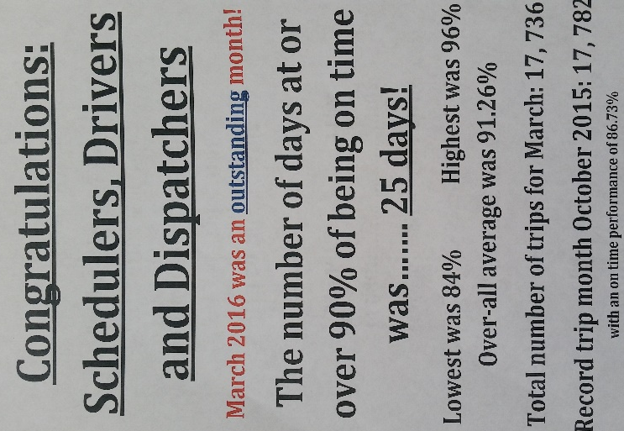 | 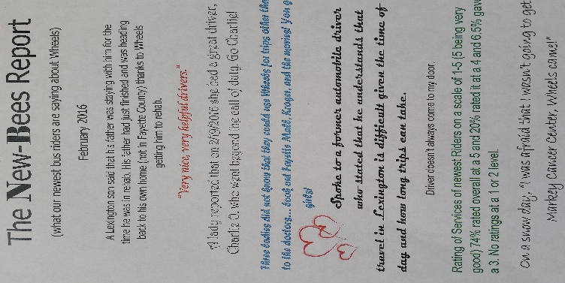 | 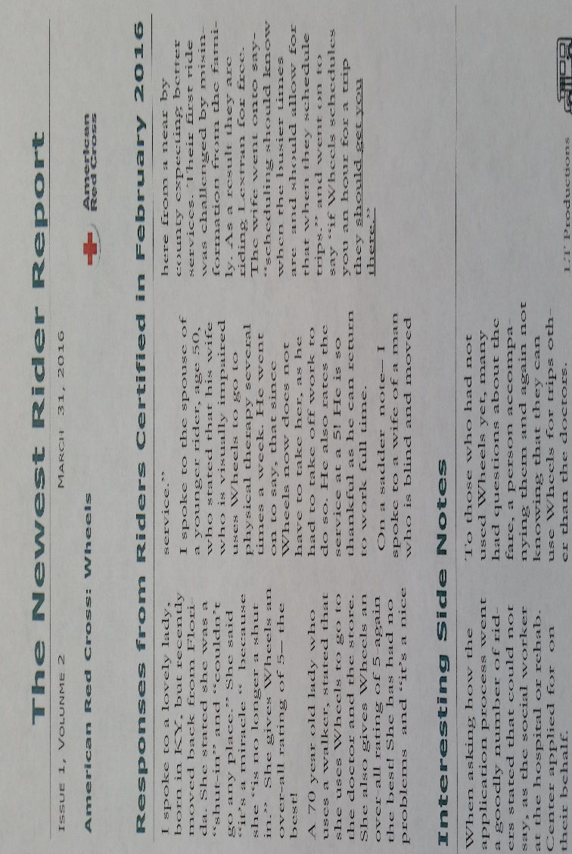

Kristy Stambaugh suggested that this information be posted on our Facebook Page. David Goodpaster suggested that Laura Thomas get an award for her incredible work and being able to bridge the issues between the drivers and the staff.
- Committee Updates:
  - Where Not To Park: Kritsy Stambaugh reported that if there any complaints please send them to her.
  - Communications: Jill Barnett reported that they were unable to find a location for the town meeting. The location for the next town meeting is to be at the new Senior Center and more discussion will be done on possible dates. It was agreed that we will ask vendors if their donations can be extended to our next town hall meeting.
  - I-know Expo: Marie Allison reported that the event was a huge success and that 1000 people attended.
  - Transportation: Laura Thomas reported on May 26th from 2 to 4 there will be a meeting where all transportation providers come together to get on the same page and discuss how to become more efficient and accessible.
Adjournment: Tiffany Bryant made a motion to adjourn at 11:27 AM, second by Roger Daman, motion carried.
Respectfully submitted,

Tiffany Bryant, Secretary

